Spring Security入门Demo

一、Spring Security简介

Spring Security，这是一种基于Spring AOP和Servlet过滤器的安全框架。它提供全面的安全性解决方案，同时在Web请求级和方法调用级处理身份确认和授权。在Spring Framework基础上，Spring Security充分利用了依赖注入（DI，Dependency Injection）和面向切面技术。

二、建立工程

我们的项目目录结构最终是:

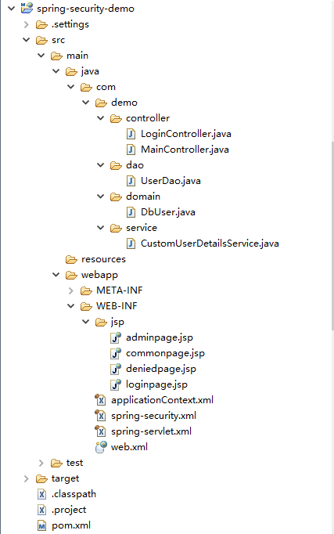

三、源代码

1 pom.xml里引入所需要的包

<project xmlns=*"http://maven.apache.org/POM/4.0.0"* xmlns:xsi=*"http://www.w3.org/2001/XMLSchema-instance"* xsi:schemaLocation=*"http://maven.apache.org/POM/4.0.0 http://maven.apache.org/xsd/maven-4.0.0.xsd"*>

<modelVersion>4.0.0</modelVersion>

<groupId>spring-security-demo</groupId>

<artifactId>spring-security-demo</artifactId>

<version>0.0.1-SNAPSHOT</version>

<packaging>war</packaging>

<name>spring-security-demo</name>

<description/>

<properties>

<project.build.sourceEncoding>UTF-8</project.build.sourceEncoding>

</properties>

<dependencies>

<dependency>

<groupId>javax</groupId>

<artifactId>javaee-api</artifactId>

<version>7.0</version>

<scope>provided</scope>

</dependency>

<dependency>

<groupId>jstl</groupId>

<artifactId>jstl</artifactId>

<version>1.2</version>

</dependency>

<dependency>

<groupId>org.springframework</groupId>

<artifactId>spring-webmvc</artifactId>

<version>3.2.9.RELEASE</version>

<type>jar</type>

<scope>compile</scope>

</dependency>

<dependency>

<groupId>org.springframework</groupId>

<artifactId>spring-context</artifactId>

<version>3.2.9.RELEASE</version>

</dependency>

<dependency>

<groupId>org.springframework.security</groupId>

<artifactId>spring-security-config</artifactId>

<version>3.1.6.RELEASE</version>

<type>jar</type>

<scope>compile</scope>

</dependency>

<dependency>

<groupId>org.springframework.security</groupId>

<artifactId>spring-security-taglibs</artifactId>

<version>3.1.6.RELEASE</version>

<type>jar</type>

<scope>compile</scope>

</dependency>

<dependency>

<groupId>log4j</groupId>

<artifactId>log4j</artifactId>

<version>1.2.15</version>

<type>jar</type>

<scope>compile</scope>

</dependency>

</dependencies>

</project>

2 web.xml

<?xml version=*"1.0"* encoding=*"UTF-8"*?>

<web-app xmlns:xsi=*"http://www.w3.org/2001/XMLSchema-instance"* xmlns=*"http://xmlns.jcp.org/xml/ns/javaee"* xsi:schemaLocation=*"http://xmlns.jcp.org/xml/ns/javaee http://xmlns.jcp.org/xml/ns/javaee/web-app_3_1.xsd"* id=*"WebApp_ID"* version=*"3.1"*>

<display-name>spring-security-demo</display-name>

<filter>

<filter-name>springSecurityFilterChain</filter-name>

<filter-class>org.springframework.web.filter.DelegatingFilterProxy</filter-class>

</filter>

<filter-mapping>

<filter-name>springSecurityFilterChain</filter-name>

<url-pattern>/*</url-pattern>

</filter-mapping>

<context-param>

<param-name>contextConfigLocation</param-name>

<param-value>

/WEB-INF/spring-security.xml

/WEB-INF/applicationContext.xml

</param-value>

</context-param>

<servlet>

<servlet-name>spring</servlet-name>

<servlet-class>org.springframework.web.servlet.DispatcherServlet</servlet-class>

<load-on-startup>1</load-on-startup>

</servlet>

<servlet-mapping>

<servlet-name>spring</servlet-name>

<url-pattern>/</url-pattern>

</servlet-mapping>

<listener>

<listener-class>org.springframework.web.context.ContextLoaderListener</listener-class>

</listener>

</web-app>

这里两处关于spring security的配置表示项目中所有路径的资源都要经过Spring Security。

注意：最好是将DelegatingFilterProxy写在DispatcherServlet之前，否则Spring Security可能不会正常工作。

3 spring-servlet.xml

<?xml version=*"1.0"* encoding=*"UTF-8"*?>

<beans xmlns=*"http://www.springframework.org/schema/beans"*

xmlns:xsi=*"http://www.w3.org/2001/XMLSchema-instance"* xmlns:p=*"http://www.springframework.org/schema/p"*

xsi:schemaLocation=*"http://www.springframework.org/schema/beans*

*http://www.springframework.org/schema/beans/spring-beans-3.0.xsd"*>

<!-- 定义一个视图解析器 -->

<bean id=*"viewResolver"*

class=*"org.springframework.web.servlet.view.InternalResourceViewResolver"*

p:prefix=*"/WEB-INF/jsp/"* p:suffix=*".jsp"* />

</beans>

这个XML配置声明一个视图解析器.在控制器中会根据JSP名映射到/ WEB-INF/jsp中相应的位置。

4 applicationContext.xml

<?xml version=*"1.0"* encoding=*"UTF-8"*?>

<beans xmlns=*"http://www.springframework.org/schema/beans"*

xmlns:xsi=*"http://www.w3.org/2001/XMLSchema-instance"*

xmlns:context=*"http://www.springframework.org/schema/context"*

xmlns:mvc=*"http://www.springframework.org/schema/mvc"*

xsi:schemaLocation=*"http://www.springframework.org/schema/beans*

*http://www.springframework.org/schema/beans/spring-beans-3.0.xsd*

*http://www.springframework.org/schema/context*

*http://www.springframework.org/schema/context/spring-context-3.0.xsd*

*http://www.springframework.org/schema/mvc*

*http://www.springframework.org/schema/mvc/spring-mvc-3.0.xsd"*>

<!-- 激活spring的注解. -->

<context:annotation-config />

<!-- 扫描注解组件并且自动的注入spring beans中.

例如,他会扫描@Controller 和@Service下的文件.所以确保此base-package设置正确. -->

<context:component-scan base-package=*"com.demo"* />

<!-- 配置注解驱动的Spring MVC Controller 的编程模型.注:次标签只在 Servlet MVC工作! -->

<mvc:annotation-driven />

</beans>

5 spring-security.xml

<?xml version=*"1.0"* encoding=*"UTF-8"*?>

<beans xmlns=*"http://www.springframework.org/schema/beans"*

xmlns:xsi=*"http://www.w3.org/2001/XMLSchema-instance"*

xmlns:security=*"http://www.springframework.org/schema/security"*

xsi:schemaLocation=*"http://www.springframework.org/schema/beans*

*http://www.springframework.org/schema/beans/spring-beans-3.0.xsd*

*http://www.springframework.org/schema/security*

*http://www.springframework.org/schema/security/spring-security-3.1.xsd"*>

<!-- Spring-Security 的配置 -->

<!-- 注意use-expressions=true.表示开启表达式,否则表达式将不可用.

see:http://www.family168.com/tutorial/springsecurity3/html/el-access.html

-->

<security:http auto-config=*"true"* use-expressions=*"true"* access-denied-page=*"/auth/denied"* >

<security:intercept-url pattern=*"/auth/login"* access=*"permitAll"*/>

<security:intercept-url pattern=*"/main/admin"* access=*"hasRole('ROLE_ADMIN')"*/>

<security:intercept-url pattern=*"/main/common"* access=*"hasRole('ROLE_USER')"*/>

<security:form-login

login-page=*"/auth/login"*

authentication-failure-url=*"/auth/login?error=true"*

default-target-url=*"/main/common"*/>

<security:logout

invalidate-session=*"true"*

logout-success-url=*"/auth/login"*

logout-url=*"/auth/logout"*/>

</security:http>

<!-- 指定一个自定义的authentication-manager :customUserDetailsService -->

<security:authentication-manager>

<security:authentication-provider user-service-ref=*"customUserDetailsService"*>

<security:password-encoder ref=*"passwordEncoder"*/>

</security:authentication-provider>

</security:authentication-manager>

<!-- 对密码进行MD5编码 -->

<bean class=*"org.springframework.security.authentication.encoding.Md5PasswordEncoder"* id=*"passwordEncoder"*/>

<!--

通过 customUserDetailsService,Spring会自动的用户的访问级别.

也可以理解成:以后我们和数据库操作就是通过customUserDetailsService来进行关联.

-->

<bean id=*"customUserDetailsService"* class=*"com.demo.service.CustomUserDetailsService"*/>

</beans>

分析：

（一）

这里/auth/login的权限为permitAll，表示所有人都可以访问此页面；/main/admin的权限为ROLE_ADMIN，表示属于ROLE_ADMIN角色的用户才有权访问此页面；/maine/common的权限为ROLE_USER，表示属于ROLE_USER的用户才有权访问此页面。

需要注意的是我们使用了SpringEL表达式来指定角色的访问.

以下是表达式对应的用法：

hasRole([role]) 返回 true 如果当前主体拥有特定角色。

hasAnyRole([role1,role2]) 返回 true 如果当前主体拥有任何一个提供的角色 （使用逗号分隔的字符串队列）

principal 允许直接访问主体对象，表示当前用户

authentication 允许直接访问当前 Authentication对象 从SecurityContext中获得

permitAll 一直返回true

denyAll 一直返回false

isAnonymous() 如果用户是一个匿名登录的用户 就会返回 true

isRememberMe() 如果用户是通过remember-me 登录的用户 就会返回 true

isAuthenticated() 如果用户不是匿名用户就会返回true

isFullyAuthenticated() 如果用户不是通过匿名也不是通过remember-me登录的用户时， 就会返回true。

（二）

<security:form-login

login-page=*"/auth/login"*

authentication-failure-url=*"/auth/login?error=true"*

default-target-url=*"/main/common"*/>

表示通过 /auth/login这个映射进行登录.   
如果验证失败则返回一个URL:/auth/login?error=true   
如果登录成功则默认指向:/main/common

（三）

<security:logout

invalidate-session=*"true"*

logout-success-url=*"/auth/login"*

logout-url=*"/auth/logout"*/>

这里我们开启了session失效功能。注销URL为:/auth/logout；注销成功后转向:/auth/login。

（四）

<bean id=*"customUserDetailsService"* class=*"com.demo.service.CustomUserDetailsService"*/>

一个自定义的CustomUserDetailsService,是实现SpringSecurity的UserDetailsService接口,但我们重写了他即便于我们进行数据库操作.

6 loginpage.jsp

<%@ taglib uri=*"http://java.sun.com/jsp/jstl/core"* prefix=*"c"*%>

<%@ taglib uri=*"http://www.springframework.org/tags/form"* prefix=*"form"*%>

<%@ taglib uri=*"http://www.springframework.org/tags"* prefix=*"spring"*%>

<%@ page language=*"java"* contentType=*"text/html; charset=UTF-8"*

pageEncoding=*"UTF-8"*%>

<!DOCTYPE html PUBLIC "-//W3C//DTD HTML 4.01 Transitional//EN" "http://www.w3.org/TR/html4/loose.dtd">

<html>

<head>

<meta http-equiv=*"Content-Type"* content=*"text/html; charset=UTF-8"*>

<title>Insert title here</title>

</head>

<body>

<h1>Login</h1>

<div id=*"login-error"*>${error}</div>

<form action=*"../j_spring_security_check"* method=*"post"*>

<p>

<label for=*"j_username"*>Username</label> <input id=*"j_username"*

name=*"j_username"* type=*"text"* />

</p>

<p>

<label for=*"j_password"*>Password</label> <input id=*"j_password"*

name=*"j_password"* type=*"password"* />

</p>

<input type=*"submit"* value=*"Login"* />

</form>

</body>

</html>

7 commonpage.jsp

<%@ page language=*"java"* contentType=*"text/html; charset=UTF-8"*

pageEncoding=*"UTF-8"*%>

<!DOCTYPE html PUBLIC "-//W3C//DTD HTML 4.01 Transitional//EN" "http://www.w3.org/TR/html4/loose.dtd">

<html>

<head>

<meta http-equiv=*"Content-Type"* content=*"text/html; charset=UTF-8"*>

<title>Insert title here</title>

</head>

<body>

<h1>Common Page</h1>

<p>每个人都能访问的页面.</p>

<a href=*"/spring-security-demo/main/admin"*> Go AdminPage </a>

<br />

<a href=*"/spring-security-demo/auth/login"*>退出登录</a>

</body>

</html>

8 adminpage.jsp

<%@ page language=*"java"* contentType=*"text/html; charset=UTF-8"*

pageEncoding=*"UTF-8"*%>

<!DOCTYPE html PUBLIC "-//W3C//DTD HTML 4.01 Transitional//EN" "http://www.w3.org/TR/html4/loose.dtd">

<html>

<head>

<meta http-equiv=*"Content-Type"* content=*"text/html; charset=UTF-8"*>

<title>Insert title here</title>

</head>

<body>

<h1>Admin Page</h1>

<p>管理员页面</p>

<a href=*"/spring-security-demo/auth/login"*>退出登录</a>

</body>

</html>

9 deniedpage.jsp

<%@ page language=*"java"* contentType=*"text/html; charset=UTF-8"*

pageEncoding=*"UTF-8"*%>

<!DOCTYPE html PUBLIC "-//W3C//DTD HTML 4.01 Transitional//EN" "http://www.w3.org/TR/html4/loose.dtd">

<html>

<head>

<meta http-equiv=*"Content-Type"* content=*"text/html; charset=UTF-8"*>

<title>Insert title here</title>

</head>

<body>

<h1>你的权限不够!</h1>

<p>只有拥有Admin权限才能访问!</p>

<a href=*"/spring-security-demo/auth/login"*>退出登录</a>

</body>

</html>

10 数据模型DbUser.java

**package** com.demo.domain;

**public** **class** DbUser {

**private** String username;

**private** String password;

**private** Integer access;

**public** String getUsername() {

**return** username;

}

**public** **void** setUsername(String username) {

**this**.username = username;

}

**public** String getPassword() {

**return** password;

}

**public** **void** setPassword(String password) {

**this**.password = password;

}

**public** Integer getAccess() {

**return** access;

}

**public** **void** setAccess(Integer access) {

**this**.access = access;

}

}

11 UserDao.java，通过一个初始化的List来模拟数据库操作

package com.demo.dao;

import java.util.ArrayList;

import java.util.List;

import org.apache.log4j.Logger;

import com.demo.domain.DbUser;

public class UserDao {

protected static Logger logger = Logger.getLogger("dao");

public DbUser getDatabase(String username) {

List<DbUser> users = internalDatabase();

for (DbUser dbUser : users) {

if (dbUser.getUsername().equals(username) == true) {

logger.debug("User found");

return dbUser;

}

}

logger.error("User does not exist!");

throw new RuntimeException("User does not exist!");

}

/**

* 初始化数据

*/

private List<DbUser> internalDatabase() {

List<DbUser> users = new ArrayList<DbUser>();

DbUser user = null;

user = new DbUser();

user.setUsername("admin");

// "admin"经过MD5加密后

user.setPassword("21232f297a57a5a743894a0e4a801fc3");

user.setAccess(1);

users.add(user);

user = new DbUser();

user.setUsername("user");

// "user"经过MD5加密后

user.setPassword("ee11cbb19052e40b07aac0ca060c23ee");

user.setAccess(2);

users.add(user);

return users;

}

}

12 CustomUserDetailsService.java，自定义UserDetailsService,可以通过继承UserDetailsService来达到灵活的自定义UserDetailsService

**package** com.demo.service;

**import** java.util.ArrayList;

**import** java.util.Collection;

**import** java.util.List;

**import** org.apache.log4j.Logger;

**import** com.demo.dao.UserDao;

**import** com.demo.domain.DbUser;

**import** org.springframework.dao.DataAccessException;

**import** org.springframework.security.core.GrantedAuthority;

**import** org.springframework.security.core.authority.~~GrantedAuthorityImpl~~;

**import** org.springframework.security.core.userdetails.User;

**import** org.springframework.security.core.userdetails.UserDetails;

**import** org.springframework.security.core.userdetails.UserDetailsService;

**import** org.springframework.security.core.userdetails.UsernameNotFoundException;

/**

* 一个自定义的service用来和数据库进行操作. 即以后我们要通过数据库保存权限.则需要我们继承UserDetailsService

*

*/

**public** **class** CustomUserDetailsService **implements** UserDetailsService {

**protected** **static** Logger *logger* = Logger.*getLogger*("service");

**private** UserDao userDAO = **new** UserDao();

**public** UserDetails loadUserByUsername(String username)

**throws** UsernameNotFoundException, DataAccessException {

UserDetails user = **null**;

**try** {

// 搜索数据库以匹配用户登录名.

// 我们可以通过dao使用JDBC来访问数据库

DbUser dbUser = userDAO.getDatabase(username);

// Populate the Spring User object with details from the dbUser

// Here we just pass the username, password, and access level

// getAuthorities() will translate the access level to the correct

// role type

user = **new** User(dbUser.getUsername(), dbUser.getPassword()

.toLowerCase(), **true**, **true**, **true**, **true**,

getAuthorities(dbUser.getAccess()));

} **catch** (Exception e) {

*logger*.error("Error in retrieving user");

**throw** **new** UsernameNotFoundException("Error in retrieving user");

}

**return** user;

}

/**

* 获得访问角色权限

*

* **@param** access

* **@return**

*/

**public** Collection<GrantedAuthority> getAuthorities(Integer access) {

List<GrantedAuthority> authList = **new** ArrayList<GrantedAuthority>(2);

// 所有的用户默认拥有ROLE_USER权限

*logger*.debug("Grant ROLE_USER to this user");

authList.add(**new** GrantedAuthorityImpl("ROLE_USER"));

// 如果参数access为1.则拥有ROLE_ADMIN权限

**if** (access.compareTo(1) == 0) {

*logger*.debug("Grant ROLE_ADMIN to this user");

authList.add(**new** GrantedAuthorityImpl("ROLE_ADMIN"));

}

**return** authList;

}

}

13 控制器LoginController.java

package com.demo.controller;

import org.apache.log4j.Logger;

import org.springframework.stereotype.Controller;

import org.springframework.ui.ModelMap;

import org.springframework.web.bind.annotation.RequestMapping;

import org.springframework.web.bind.annotation.RequestMethod;

import org.springframework.web.bind.annotation.RequestParam;

@Controller

@RequestMapping("auth")

public class LoginController {

protected static Logger logger = Logger.getLogger("controller");

/**

* 指向登录页面

*/

@RequestMapping(value = "/login", method = RequestMethod.GET)

public String getLoginPage(

@RequestParam(value = "error", required = false) boolean error,

ModelMap model) {

logger.debug("Received request to show login page");

if (error == true) {

// Assign an error message

model.put("error",

"You have entered an invalid username or password!");

} else {

model.put("error", "");

}

return "loginpage";

}

/**

* 指定无访问额权限页面

*

* @return

*/

@RequestMapping(value = "/denied", method = RequestMethod.GET)

public String getDeniedPage() {

logger.debug("Received request to show denied page");

return "deniedpage";

}

}

该controller有两个mapping映射

main/common

main/admin

现在我们将同过Spring Security框架实现成功登陆的人都能访问到main/common，但只有拥有admin权限的用户才能访问main/admin。

14 控制器MainController.java

package com.demo.controller;

import org.apache.log4j.Logger;

import org.springframework.stereotype.Controller;

import org.springframework.web.bind.annotation.RequestMapping;

import org.springframework.web.bind.annotation.RequestMethod;

@Controller

@RequestMapping("/main")

public class MainController {

protected static Logger logger = Logger.getLogger("controller");

/**

* 跳转到commonpage页面

*

* @return

*/

@RequestMapping(value = "/common", method = RequestMethod.GET)

public String getCommonPage() {

logger.debug("Received request to show common page");

return "commonpage";

}

/**

* 跳转到adminpage页面

*

* @return

*/

@RequestMapping(value = "/admin", method = RequestMethod.GET)

public String getAadminPage() {

logger.debug("Received request to show admin page");

return "adminpage";

}

}

四、运行结果

1 启动spring-security-demo程序

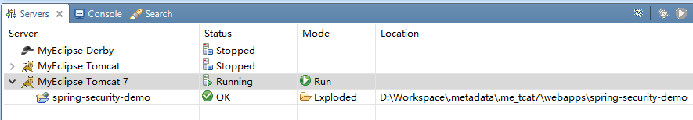

2 在浏览器里输入<http://localhost:8080/spring-security-demo/auth/login>

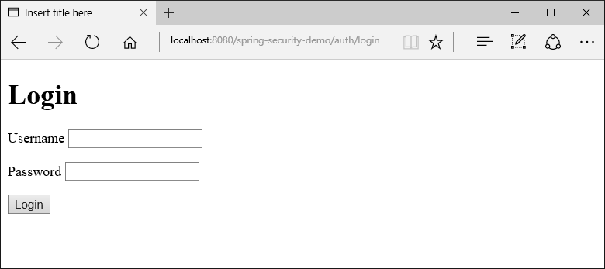

3 输入用户名admin密码admin后，点击“Login”按纽

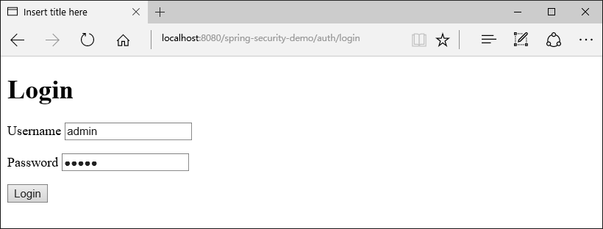

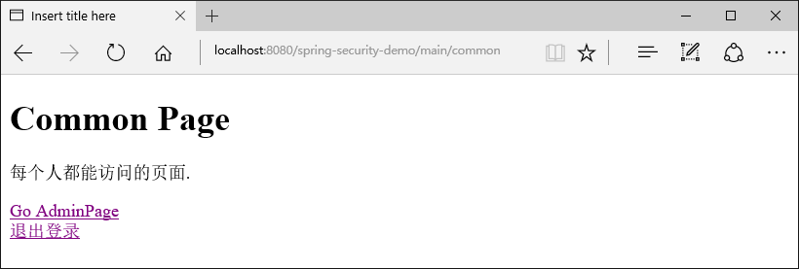

4 点击“Go AdminPage”链接，因为有权限，所以可看到管理员页面

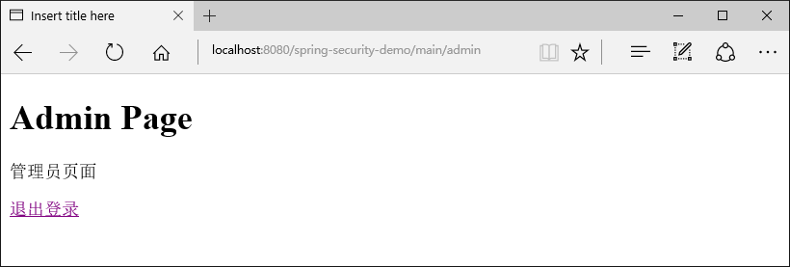

5 点击“退出登录”，返回登录页

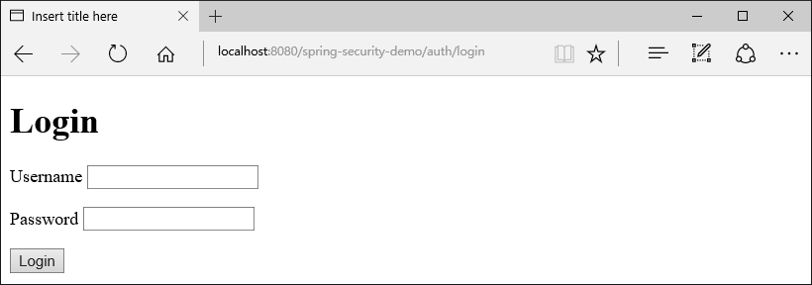

6 输入用户名user密码user并登录

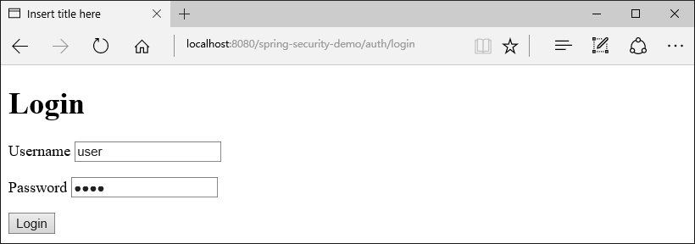

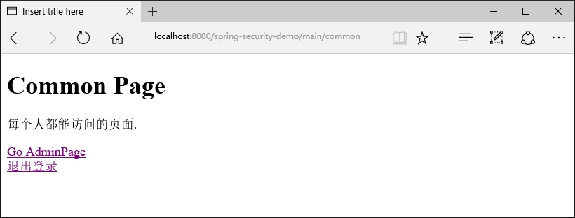

7 点击Go AdminPage链接，因为没有权限，所以看到权限不够的提示

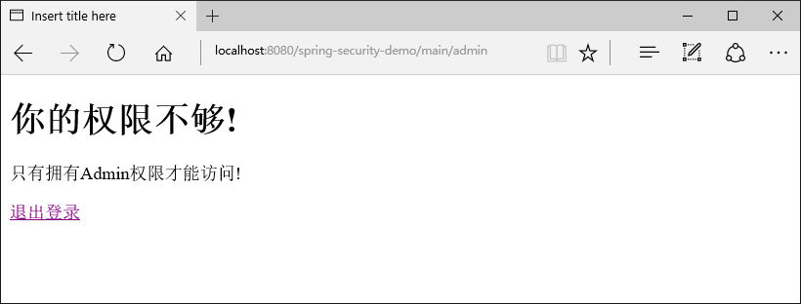

8 退出登录，返回登录页

